### Annexure-I

**JAAGO RE**

### A Mini-Project Report

### Under

### Project Workshop

**Implementation of Technology**

***Submitted by***

**Siddhi Khamitkar**

**Utkarsha Mahajan**

**Disha Mishra**

**Mansi Virani**

***Under The Guidance Of***

**Mudit Kapoor**

***in partial fulfillment for the award of the degree of***

### B-tech

**Computer Science**

## At



**MUKESH PATEL SCHOOL OF TECHNOLOGY MANAGEMENT AND ENGINEERING, MUMBAI**

**MAY 2016**

### Annexure-II

## CERTIFICATE

This is to certify that the project entitled “Jaago Re” is the bonafide work carried out by Siddhi Khamitkar, Utkarsha Mahajan, Disha Mishra and Mansi Virani of B.Tech (Computer Engineering), MPSTME (NMIMS), Mumbai, during the IV semester of the academic year 2014, in partial fulfillment of the requirements for the award of the Degree of Bachelors of Technology as per the norms prescribed by NMIMS. The mini-project work has been assessed and found to be satisfactory.

________________________

Mudit Kapoor

Internal Mentor

_______________________ ________________________

Examiner 1 Examiner 2

________________________

Dean

Dr. S. Y. Mhaiskar

### Annexure-III

## DECLARATION

We, Siddhi Khamitkar, Utkarsha Mahajan, Disha Mishra,Mansi Virani, Roll No. B049,B054,B057,B072, B.Tech (Computer Engineering), IV semester understand that plagiarism is defined as anyone or combination of the following:

1. Un-credited verbatim copying of individual sentences, paragraphs or illustration (such as graphs, diagrams, etc.) from any source, published or unpublished, including the internet.
2. Un-credited improper paraphrasing of pages paragraphs (changing a few words phrases, or rearranging the original sentence order)
3. Credited verbatim copying of a major portion of a paper (or thesis chapter) without clear delineation of who did wrote what. (Source: IEEE, The institute, Dec. 2004)
4. I have made sure that all the ideas, expressions, graphs, diagrams, etc., that are not a result of my work, are properly credited. Long phrases or sentences that had to be used verbatim from published literature have been clearly identified using quotation marks.
5. I affirm that no portion of my work can be considered as plagiarism and I take full responsibility if such a complaint occurs. I understand fully well that the guide of the seminar/ project report may not be in a position to check for the possibility of such incidences of plagiarism in this body of work.

Signature of the Student:

Siddhi Khamitkar (B049)

Utkarsha Mahajan (B054)

Disha Mishra (B057)

Mansi Virani (B072)

Place: Mumbai,MPSTME

Date: 26/4/14

## Annexure IV

## Table of contents

|  |  |  |  |  |  |  |  |  |
| --- | --- | --- | --- | --- | --- | --- | --- | --- |
| **CHAPTER NO.** | | |  |  | **TITLE** |  | **PAGE NO.** | |
|  |  |  |  |  | Acknowledgement  Abstract |  | 1  2 |  |

1. Introduction 4
   1. Project Overview 11
   2. Hardware Requirements 12
   3. Software Requirements 12
2. Installation and setup 13
   1. Getting Android SDK 13
   2. Setting up ADT bundle 14
   3. Installing Eclipse plugin 14
3. Analysis and Design 19
4. The Alarm Clock 21
   1. Activity_Buzzer.java 21
   2. MyAlarm.java 22
   3. Myservice.java 23
   4. Myreceiver.java 23
   5. AlarmMainActivity.java 23
5. Puzzles 24
   1. Puzzle 1 24
   2. Puzzle 2 25
   3. Puzzle 3 25
   4. Assurance Test 27
6. Integration 28
7. Graphical User Interface (GUI) 28
8. Conclusion and future scope 31
9. Appendices 32
10. References 49

### Annexure V

## List of Figures

**CHAPTER NO. FIG TITLE PAGE NO.**

1. Introduction

1.1 Brief History of Android 4

* 1. Existing apps in the market 11

1. Installation and setup

2.1 Screenshot of SDK manager 18

1. Analysis and design

3.1 Survey showing ways of getting up 19

1. The Alarm Clock

4.1 Activity_Buzzer XML layout 21

4.2 My alarm XML layout 22

4.3 Myservice XML layout 23

5. Puzzles

5.1 Squares xml layout 24

5.2 Diff.xml layout output 25

5.3 MathEq.xmlLayout 26

5.4 MathEq.xml layout output for incorrect input

26

5.5 MathEq.xml layout output for correct output

5.6 Captcha layout output 27

5.7 Captcha with invalid 27

5.8 Captcha with correct 27

6. Integration

6.1 Calling intents in alarm 28

7 Graphical user interface 29

7.1 Main Alarm layout 29

7.2 Notification screen icon 29

7.3 layout of puzzle 1 30

7.4 GUI layout of puzzle 2 30

7.5 GUI layout of puzzle 3 30

7.6 GUI layout of captcha 30

### Annexure VI

## List of Tables

**CHAPTER NO. TABLE NO. TITLE PAGE NO**

1. Introduction
   1. Comparison b/w beta & astro 5
   2. Description about Android Cupcake 1.5 5
   3. Description about Android Donut 1.6 6
   4. Description about Android Éclair 2.0/2.1 6
   5. Description about Android Froyo 2.2 7
   6. Description about Android Gingerbread 2.3 7
   7. Description about Android Honeycomb 3.0 8
   8. Description about Android ICS 4.0 8
   9. Description about Android Jellybean 4.2 9
   10. Description about Android KitKat 4.4 10
2. Installation and setup

2.1 Details of ADT zip file 16

**ACKNOWLEDGEMENT**

I would like to thank our IOT Lab professor Ratnesh Chaturvedi for his help and suggestions.

I would also like to thank our mentor Mr. Mudit Kapoor for his constant guide and support.

Last but not the least I would thank my fellow classmates Rajas Jambekar for his help.

**ABSTRACT**

**PURPOSE OF THE STUDY**

We all face this problem of not getting up on time for work, snoozing our alarms until we’re already late and then hurrying for the work thus missing on some basic requirements such as food, office stuff and sometimes even bathing.

Thus we introduce an android app that aims at waking you up on time with the help of a small brain booster that diverts your sub-conscious mind from deep sleep to a logic problem that you have to solve to stop/snooze the alarm failing to which the alarm doesn’t stop!



**MAJOR FINDINGS**

We observe that most of the people wake up due to a mobile phone as compared to other electronic devices. Hence we aim at making an android app that can be installed in mobile phones and which helps you to wake up with a good head start.

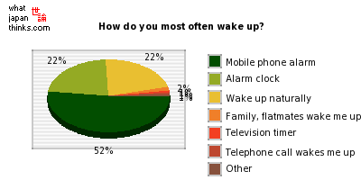

**EXISTING SYSTEMS**

|  |  |  |  |  |
| --- | --- | --- | --- | --- |
| Good reviews: None. | PUZZLE RISE  http://a2.mzstatic.com/us/r1000/040/Purple/71/a2/16/mzl.jqpwbdms.320x480-75.jpg | | Bad reviews:   * Good idea but poorly executed. * I can't set multiple alarms. * It doesn't offer any instructions or anything of that sort. * I think it needs more brain-stimulating puzzles. | |
| Good reviews:   * The best alarm clock out there. * It’s the best free clock app I have seen. * Awesome alarm clock. | PUZZLE ALARM CLOCK    http://a1.mzstatic.com/us/r1000/082/Purple/v4/8a/3f/05/8a3f0539-c4e2-e197-f211-4a836e9927a0/mzl.fddxkfny.1136x1136-75.jpg | Bad reviews:   * Annoying and very bad qualities. * Doesn't ring. * Can't edit alarms after creating them. * Only works if left on all night. | |

**METHODOLOGY USED**

The first and the foremost step is the installation of ADT Bundle which includes everything necessary for the creation of an app. It includes the following things:

* Eclipse

It is the main platform where the app is created. It provides various types of projects such as android application project, java project, class files etc. The user can choose any of the mentioned project as per the need. The projects are written in java language.

* SDK Manager

A [software](http://www.webopedia.com/TERM/S/software.html) development kit that enables developers to create [applications](http://www.webopedia.com/TERM/A/application.html) for the [Android platform](http://www.webopedia.com/TERM/A/Android_platform.html). The Android [SDK](http://www.webopedia.com/TERM/S/SDK.html) includes sample projects with [source code](http://www.webopedia.com/TERM/S/source_code.html), development tools, an [emulator](http://www.webopedia.com/TERM/E/emulator.html), and required libraries to build Android applications.

**INTRODUCTION**

* Android is a software platform and operating system developed initially for mobiles.
* It is an open source and Linux-based Operating System for mobile devices:
* Android is [open source](http://en.wikipedia.org/wiki/Open_source) and Google releases the [source code](http://en.wikipedia.org/wiki/Source_code) under the [Apache License](http://en.wikipedia.org/wiki/Apache_License). This open-source code and permissive licensing allows the software to be freely modified and distributed by device manufacturers, wireless carriers and enthusiast developers.
* It is based on the Linux kernel.

History:

Android was found way back in 2003. It was developed in Palo Alto, California by Andy Rubin, Rich Miner, Nick Sears and Chris White. It was purchased by the GOOGLE in AUGUST, 2005 for 50 million $.

* It is a software stack for mobile devices that includes:
* An operating system
* Middleware
* Key Applications
* The [user interface](http://en.wikipedia.org/wiki/User_interface) of Android is based on [direct manipulation](http://en.wikipedia.org/wiki/Direct_manipulation), using touch inputs that loosely correspond to real-world actions, like swiping, tapping, pinching and reverse pinching to manipulate on-screen objects.
* Android is the world's most widely used smartphone platform, overtaking [Symbian](http://en.wikipedia.org/wiki/Symbian) in the fourth quarter of 2010. Android is popular with technology companies who require a ready-made, low-cost, customizable and lightweight operating system for [high tech](http://en.wikipedia.org/wiki/High_tech) devices. Despite being primarily designed for phones and tablets, it also has been used in televisions, [games consoles](http://en.wikipedia.org/wiki/Games_console), [digital cameras](http://en.wikipedia.org/wiki/Digital_camera) and other electronics.

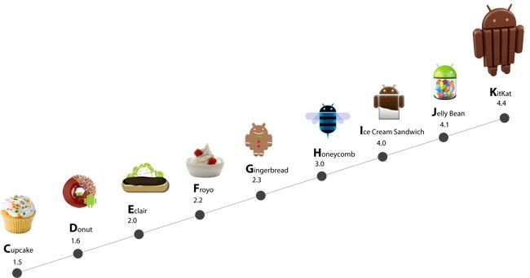

**Fig 1.1 Brief history of android. This figure shows the evolution of android over time.**

Description in brief about the various versions of android.

|  |  |
| --- | --- |
| Android Beta   * First Version of Android. * The focus of Android beta is testing incorporating usability. * Android beta will generally have many more problems on speed and performance. | Android Astro 1.0   * First full version of android. * Released on September 23, 2008. * Wi-Fi and Bluetooth support. * Quite slow in operating. * Copy and Paste feature in the web browser is not present. |

**Table 1.1 Comparison between android Beta and Android astro 1.0**

**This table shows the basic difference of android operating systems and also shows the addition of various features with new versions released with time.**

|  |  |
| --- | --- |
| Android Cupcake 1.5   * Released on April 30, 2009. * Added auto-rotation option. * Copy and Paste feature added in the web browser. * Increased speed and performance but not upto required level. | <http://teckhamsterblog.files.wordpress.com/2010/12/cupcake.jpg> |

**Table 1.2 Description about Android cupcake 1.5**

**This table describes in brief about the features added in the android version 1.5, also called cupcake.**

|  |  |
| --- | --- |
| Android Donut 1.6   * Released on September 15, 2009. * Voice search and Search box were added. * Faster OS boot times and fast web browsing   experience.   * Typing is quite slower. | <http://the-gadgeteer.com/wp-content/uploads/2009/10/Android-1.6-Donut.jpg> |

**Table 1.3 Description about Android donut 1.6**

|  |  |
| --- | --- |
| Android Eclair 2.0/2.1   * Released on October 26, 2009. * Bluetooth 2.1 support. * Improved typing speed on virtual keyboard, with smarter   dictionary.   * No Adobe flash media support. | <http://ticker.ttsh.netdna-cdn.com/wp-content/uploads/2009/10/android-ecliar.jpg> |

**Table 1.4 Description about android éclair 2.0 / 2.1**

**This shows the features as well as limitations of the android 2.0. it is given the name éclair.**

|  |  |
| --- | --- |
| Android Froyo 2.2   * Released on  May 20, 2010. * Support for Adobe Flash 10.1 * Improved Application launcher with better browser * No internet calling. | <http://www.signature9.com/wp-content/uploads/2010/06/android_froyo.jpg> |

**Table 1.5 Description about Android Froyo 2.2**

**This shows the features and limitations of the android version 2.2. it is called Froyo commonly and right next to it shows the figure of the same.**

|  |  |
| --- | --- |
| Android Gingerbread 2.3   * Released on  December 6, 2010. * Updated User Interface with high efficiency and speed * Internet calling * One touch word selection and copy/paste. * New keyboard for faster word input. * More successful version of Android than previous versions. * not supports multi-core processors. | <http://i.zdnet.com/blogs/gingerdroid.png> |

**Table 1.6 Description about android gingerbread 2.3**

**This shows the features as well as the figure alongside it of the android version 2.3. It is commonly called Gingerbread.**

|  |  |
| --- | --- |
| Android Honeycomb 3.0   * Released on February 22, 2011. * Support for multi-core processors * Ability to encrypt all user data. * This version of android is only available for tablets. | <http://cdn4.digitaltrends.com/wp-content/uploads/2011/01/android-3-0-honeycomb-official-logo.jpg> |

**Table 1.7 Descriptions about Android Honeycomb 3.0**

**This shows detail about the operating system alongside its pictorial depiction. it has version 3.0 with added features and is commonly called Honeycomb.**

|  |  |
| --- | --- |
| Android IceCreamSandwich(ICS) 4.0   * Released on November 14, 2011. * Virtual button in the UI. * Improved text input and spell-checking * Ability to shut down apps that are using data in the background. | <http://www.geek.com/wp-content/uploads/2011/08/android_ice-cream-sandwich-580x423.jpg> |

**Table 1.8 Description about Android IceCream Sandwich (ICS) 4.0**

**This table describes about android 4.0. It is also commonly called IceCream Sanwich or ICS.**

|  |  |
| --- | --- |
| Android JellyBean 4.2   * Released on November 13, 2012. * Latest version of Android. * Smoother user interface. * Moving between home screens and switching between apps is effortless, like turning the pages of a book. * Jelly Bean has more reactive and uniform touch responses, and makes your Android device even more responsive * A completely redesigned camera app with new tools for taking photos. * The clock has been totally redesigned with an all new look which includes both a digital and analog clock style. |  |

**Table 1.9 Description about Jellybean 4.2**

**This table describes Android version 4.2 having its pictorial depiction alongside.**

|  |  |
| --- | --- |
| Android KitKat 4.4   * Screen recording * KitKat is designed to run on devices with as little as 512MB of RAM * A new Hangouts app consolidates all of your text and multimedia messages, conversations, and video calls in one place * Performance improvements * Now you can print photos, documents, and web pages directly from your phone |  |

**Table 1.10 Description about Android KitKat 4.4**

**This table describes the features of the operating system. It is the latest software available in use in the world and has a version of 4.4. It is been named as KitKat.**

FEATURES OF ANDROID

* Android is a multi-process system, in which each application (and parts of the system) runs in its own process.
* Interface is better than the previous touch screen mobiles.
* GSM/EDGE, Bluetooth, Wi-Fi, NFC and WiMAX.
* Storage: SQLite, a lightweight relational database is used for data storage purposes.
* Web browser: Based on the open-source WebKit layout engine, coupled with Chrome's V8 JavaScript engine supporting HTML5 and CSS3.
* Multi-tasking : User can jump from one task to another and at the same time various application can run simultaneously.
* Resizable widgets: Widgets are resizable, so users can expand them to show more content or shrink them to save space.
* Android supports advanced audio/video/still media formats such as MPEG-4, H.264, MP3, and AAC, AMR, JPEG, PNG, GIF.
* Developing an android application is not tough using SDK(standard development kit) and java emulator.
  1. **PROJECT OVERVIEW**

We all face this problem of not getting up on time for work, snoozing our alarms until we’re already late and then hurrying for the work thus missing on some basic requirements such as food, office stuff and sometimes even bathing.

Thus we introduce an android app that aims at waking you up on time with the help of a small brain booster that diverts your sub-conscious mind from deep sleep to a logic problem that you have to solve to stop/snooze the alarm failing to which the alarm doesn’t stop!

The basic idea of our app:

* The app basically diverts your mind from sleeping to solving a random puzzle.
* This makes you think deeply and eventually wakes you up.
* And the best part-The alarm doesn’t go off unless the puzzle is solved.

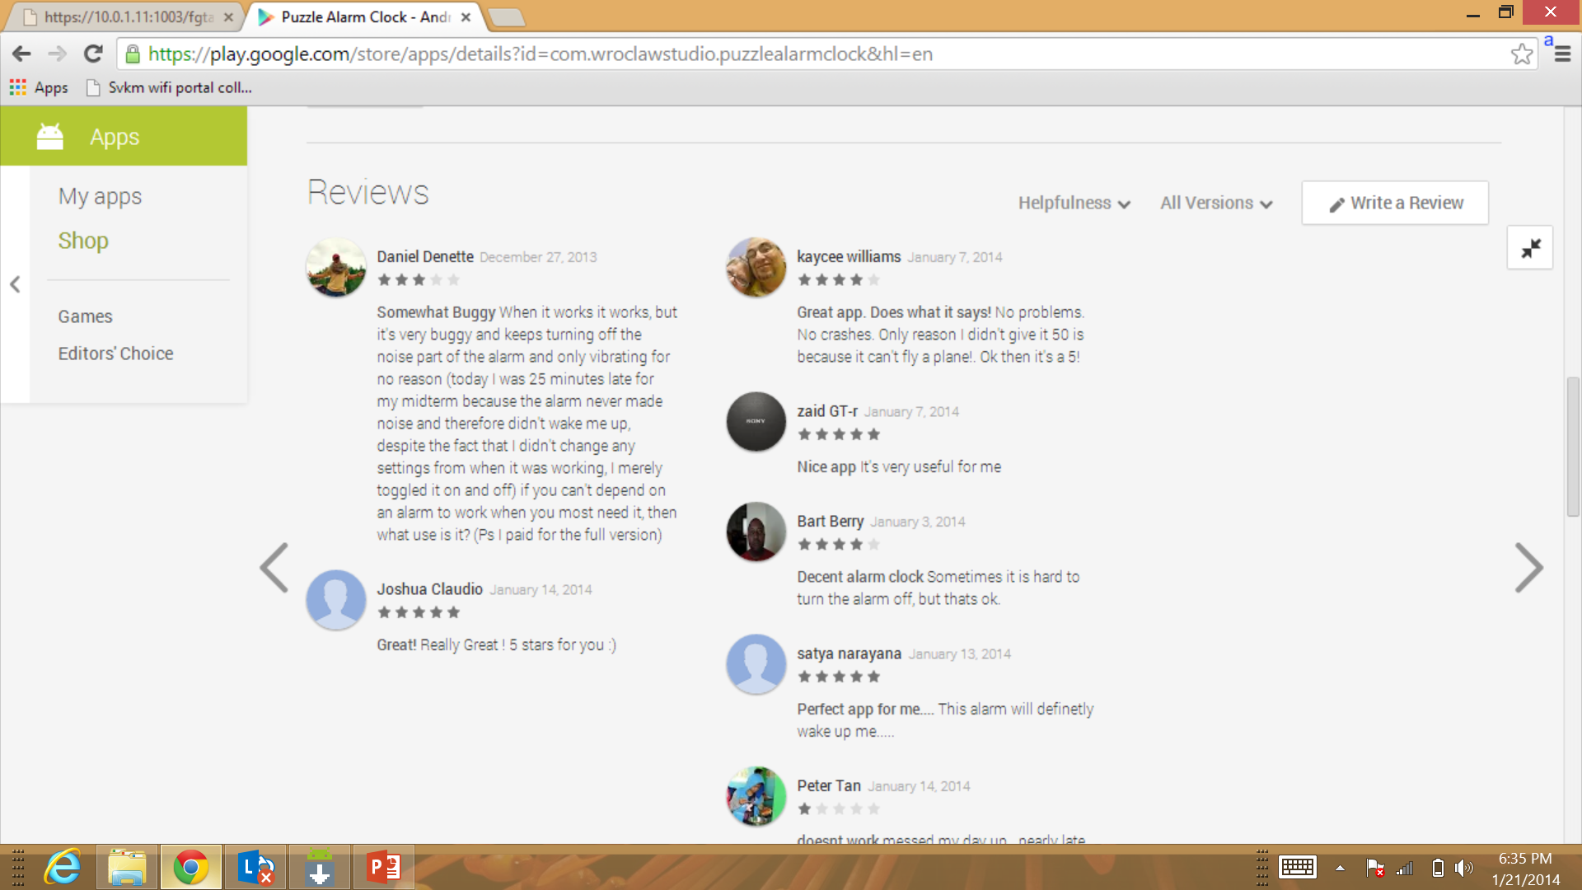

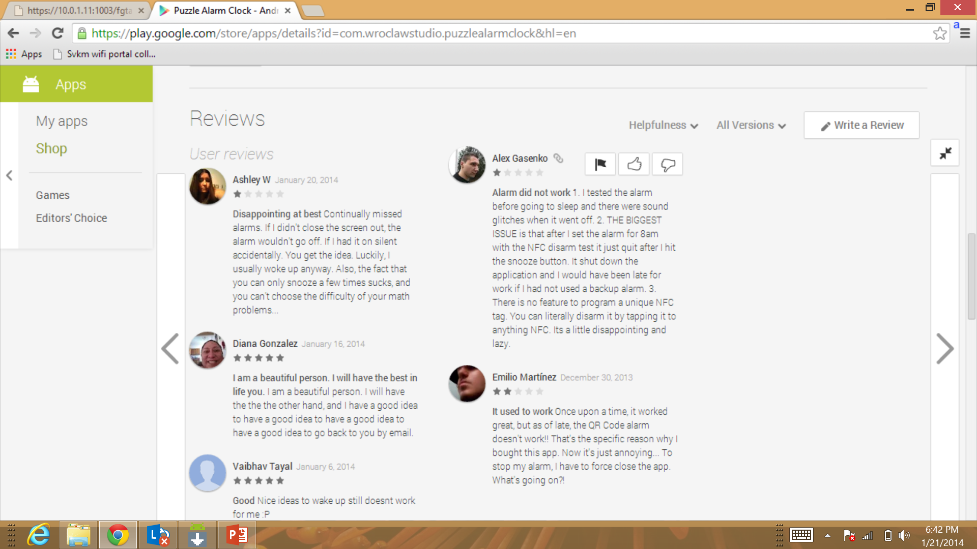 

**Fig 1.2 Existing Apps in the market**

**The figures lists down 3 out of a few existing apps already present in the android market and review.**

* 1. **HARDWARE SPECIFICATION OF THE SYSTEM (Aakash):**

1. The hardware specifications of the system used to develop the app: Windows 8
2. The hardware specifications of the system used to deploy the app: Aakash Tablet with android version 4.0.4

**1.3 SOFTWARE SPECIFICATION:**

1. Android API level 10.
2. IDE: Eclipse Helios Service Release 2
3. Emulator: Android 4.1

**INSTALLATION AND SETUP**

The entire process is divided into 3 parts that can be performed step by step in order to make the device ready to use. These include

1. Getting the android SDK
2. Setting up the ADT bundle
3. Installing the eclipse plugin

**2.1 GETTING THE ANDROID SDK:**

The Android SDK provides you the API libraries and developer tools necessary to build, test, and debug apps for Android.

It includes the essential Android SDK components and a version of the Eclipse IDE with built-in **ADT (Android Developer Tools)** to streamline your Android app development.

With a single download, the ADT Bundle includes everything you need to begin developing apps:

1. Eclipse + ADT plugin
2. Android SDK Tools
3. Android Platform-tools
4. The latest Android platform
5. The latest Android system image for the emulator

**Getting started on Windows**

Your download package is an executable file that starts an installer. The installer checks your machine for required tools, such as the proper Java SE Development Kit (JDK) and installs it if necessary. The installer then saves the Android SDK Tools into a default location (or you can specify the location).

* Double-click the executable (.exe file) to start the install.
* Make a note of the name and location in which it saves the SDK on your system—you will need to refer to the SDK directory later, when setting up the ADT plugin and when using the SDK tools from the command line.
* Once the installation completes, the installer offers to start the Android SDK Manager. If you'll be using Eclipse, **do not** start the Android SDK Manager, and instead move on to [Installing the Eclipse Plugin](http://developer.android.com/sdk/installing/installing-adt.html).

If you're using a different IDE, start the SDK Manager and read [Adding Platforms and Packages](http://developer.android.com/sdk/installing/adding-packages.html).

**2.2 SETTING UP ADT BUNDLE:**

The ADT Bundle provides everything you need to start developing apps, including a version of the Eclipse IDE with built-in **ADT (Android Developer Tools)** to streamline your Android app development. If you haven't already, go download the [Android ADT Bundle](http://developer.android.com/sdk/index.html). (If you downloaded the SDK Tools only, for use with an existing IDE, you should instead read [Setting Up an Existing IDE](http://developer.android.com/sdk/installing/index.html).)

**Install the SDK and Eclipse IDE**

* Unpack the ZIP file (named adt-bundle-<os_platform>.zip) and save it to an appropriate location, such as a "Development" directory in your home directory.
* Open the adt-bundle-<os_platform>/eclipse/ directory and launch **eclipse**.

That's it! The IDE is already loaded with the Android Developer Tools plugin and the SDK is ready to go. To start developing, read [Building Your First App](http://developer.android.com/training/basics/firstapp/index.html).

**Caution:** Do not move any of the files or directories from the adt-bundle-<os_platform> directory. If you move theeclipse or sdk directory, ADT will not be able to locate the SDK and you'll need to manually update the ADT preferences.

**2.3 INSTALLING THE ECLIPSE PLUG IN**

Android offers a custom plugin for the Eclipse IDE, called Android Development Tools (ADT). This plugin provides a powerful, integrated environment in which to develop Android apps. It extends the capabilities of Eclipse to let you quickly set up new Android projects, build an app UI, debug your app, and export signed (or unsigned) app packages (APKs) for distribution.

If you need to install Eclipse, you can download it from [eclipse.org/downloads/](http://www.eclipse.org/downloads/).

**Note:** If you prefer to work in a different IDE, you do not need to install Eclipse or ADT. Instead, you can directly use the SDK tools to build and debug your application.

**Download the ADT Plugin**

* Start Eclipse, then select **Help** > **Install New Software**.
* Click **Add**, in the top-right corner.
* In the Add Repository dialog that appears, enter "ADT Plugin" for the Name and the following URL for the Location: <https://dl-ssl.google.com/android/eclipse/>
* Click **OK**.

If you have trouble acquiring the plugin, try using "http" in the Location URL, instead of "https" (https is preferred for security reasons).

* In the Available Software dialog, select the checkbox next to Developer Tools and click **Next**.
* In the next window, you'll see a list of the tools to be downloaded. Click **Next**.
* Read and accept the license agreements, then click **Finish**.
* If you get a security warning saying that the authenticity or validity of the software can't be established, click **OK**.
* When the installation completes, restart Eclipse.

**Configure the ADT Plugin**

* Once Eclipse restarts, you must specify the location of your Android SDK directory:
* In the "Welcome to Android Development" window that appears, select **Use existing SDKs**.
* Browse and select the location of the Android SDK directory you recently downloaded and unpacked.
* Click **Next**.

Your Eclipse IDE is now set up to develop Android apps, but you need to add the latest SDK platform tools and an Android platform to your environment. To get these packages for your SDK, continue to [Adding Platforms and Packages](http://developer.android.com/sdk/installing/adding-packages.html).

**Download the ADT Translation Manager Plugin**

* The full ADT Plugin must be installed in your Eclipse environment before you install the ADT Translation Manager Plugin.
* ADT Translation Manager Plugin is designed for use with the translation services offered through the Google Play Developer Console. It is not designed for general purpose import/export of strings.
* To use the plugin, you must [set up a Developer Console account](http://developer.android.com/distribute/googleplay/publish/register.html).
* Currently, translation services are available through the Developer Console only as part of a pilot program. To use the plugin, you must first sign up for the pilot program by visiting the Developer Console.
* If you downloaded ADT as part of the SDK ADT bundle, you may encounter an error when attempting to download the ADT Translation Manager Plugin from the remote repository. In that case, open the **Install New Software**, uncheck "Contact all update sites during install to find required software" at the bottom and try again.

**Troubleshooting ADT Installation**

If you are having trouble downloading the ADT plugin after following the steps above, here are some suggestions:

* If Eclipse cannot find the remote update site containing the ADT plugin, try changing the remote site URL to use http, rather than https. That is, set the Location for the remote site to:http://dl-ssl.google.com/android/eclipse/
* If you are behind a firewall (such as a corporate firewall), make sure that you have properly configured your proxy settings in Eclipse. In Eclipse, you can configure proxy information from the main Eclipse menu in **Window** (on Mac OS X, **Eclipse**) > **Preferences** > **General** > **Network Connections**.
* If you are still unable to use Eclipse to download the ADT plugin as a remote update site, you can download the ADT zip file to your local machine and manually install it:
  + Download the ADT Plugin zip file (do not unpack it):

|  |  |  |
| --- | --- | --- |
| Package | Size | MD5 Checksum |
| [ADT-22.3.0.zip](http://dl.google.com/android/ADT-22.3.0.zip) | 14493723 bytes | 0189080b23dfa0f866adafaaafcc34ab |

**Table 2.1 Details of the adt zip file.**

**The following table shows the size along with the checksum to detect errors if any in the zip package of the ADT bundle.**

* Start Eclipse, then select **Help** > **Install New Software**
* Click **Add**, in the top-right corner.
* In the Add Repository dialog, click **Archive**.
* Select the downloaded ADT-22.3.0.zip file and click **OK**.
* Enter "ADT Plugin" for the name and click **OK**.
* In the Available Software dialog, select the checkbox next to Developer Tools and click **Next**.
* In the next window, you'll see a list of the tools to be downloaded. Click **Next**.
* Read and accept the license agreements, then click **Finish**.
* If you get a security warning saying that the authenticity or validity of the software can't be established, click **OK**.
* When the installation completes, restart Eclipse.

To update your plugin once you've installed using the zip file, you will have to follow these steps again instead of the default update instructions.

**Adding Platforms and Packages**

The Android SDK separates tools, platforms, and other components into packages you can download using the Android SDK Manager. The original SDK package you've downloaded includes only the SDK Tools. To develop an Android app, you also need to download at least one Android platform and the latest SDK Platform-tools.

* Launch the SDK Manager.
* If you've used the Windows installer to install the SDK tools, you should already have the Android SDK Manager open. Otherwise, you can launch the Android SDK Manager in one of the following ways:
  + On Windows, double-click the SDK Manager.exe file at the root of the Android SDK directory.
  + On Mac or Linux, open a terminal and navigate to the tools/ directory in the Android SDK, then execute android sdk.

The SDK Manager shows all the SDK packages available for you to add to your Android SDK. As a minimum configuration for your SDK, we recommend you install the following:

* The latest Tools packages (check the **Tools** folder).
* The latest version of Android (check the first **Android** folder).
* The Android Support Library (open the **Extras** folder and check **Android Support Library**).
* Once you've chosen your packages, click **Install**. The Android SDK Manager installs the selected packages into your Android SDK environment.

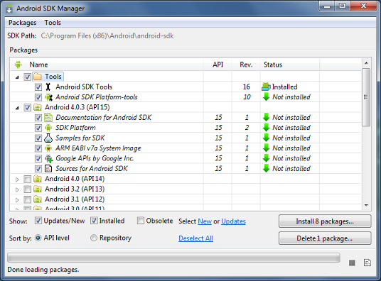

**Fig 2.1 Screenshot of the SDK manager**

**The Sdk manager shows the list of the packages and the packages installed. it also shows the list of updates for a particular package.**

With these packages installed, you're ready to start developing.

**ANALYSIS AND DESIGN**

The need of an android app came into picture when there was no need to remember long URL links for a particular purpose. It also has a quick responsive time. The other advantages of this app include having solved connectivity problem with providing a new platform for employment.

Our app is based on a real life survey conducted on people of various age groups. The main problem is waking up on time in the morning. People have problems reaching places on time due to waking up. This is mainly because we’re not able to divert our subconscious mind from sleep. And hence we keep on SNOOZING our alarm.



**Fig 3.1 Survey showing ways of getting up in the morning**

**The pie chart shows the percentage of people waking up in the morning, the maximum being mobile phone alarm (52%).**

**Truth is** - A LOT OF PEOPLE HAVE PROBLEMS WAKING UP !!For summarizing everything up, laziness as symptom, not mental factor, is people's problem of being unambitious, irresolute.

However, this problem was the basis of existence of a few existing apps in the market. But the apps received bad reviews containing bugs and thus resulted in failures.

Our app is based on the similar concept. However, we have tried to incorporate as minimal bugs as possible. The app opens up with puzzle that need to be solved in order to stop the alarm form ringing. The puzzle are in a variety and every morning a new random puzzle crops up to be solved. To ensure that the user is completely woken up, there is an assurance test made.

The assurance test is a captcha. Every time a new captcha is generated which when written correctly lets u turn off the alarm thus waking you up.

The detailed design will be discussed in the following chapters.

**THE ALARM CLOCK**

The alarm clock in android consists of 5 java classes and their related xml documents. These five classes are:

* + 1. Activity_Buzzer.java
    2. MyAlarm.java
    3. MyService.java
    4. MyReceiver.java
    5. AlarmMainActivity.java

**4.1 ACTIVITY_BUZZER.JAVA**

The java file here displays a clock and has functions of stopping the alarm or snoozing the alarm. The snooze alarm is by default five minutes and static. The user cannot change it. This is the last screen of the app. This enables user to stop the alarm.

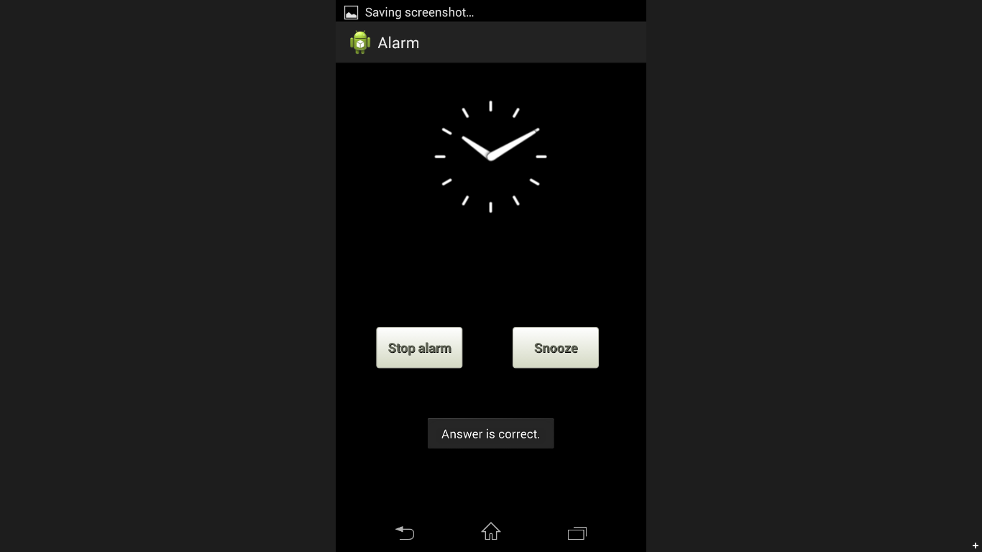

**Fig 4.1 Activity_Buzzer XML layout.**

**This layout shows two buttons having an onClick property. Also there is a clock showing the time at that particular instant.**

**4.2 MY ALARM.JAVA**

This class creates the main layout where the alarm is being set. It sets the time and clicking on start sets the alarm. Stop button delets that particular alarm and cancel button deletes all the persticual alarm made by the user.

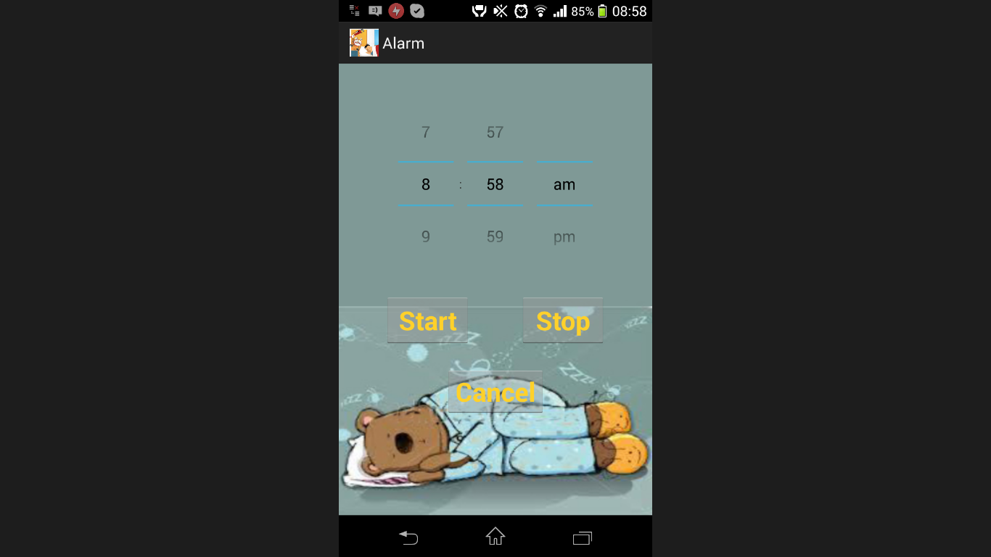

**Fig 4.2 My alarm XML layout**

**This layout has 3 buttons and sets the alarm using time picker widget available in the eclipse layout options. The background is a part of the GUI.**

**4.3 MY SERVICE.JAVA**

This receives the time set by the Myalarm.java class. Here, it contains the toast displaying the time is set and also sets the time given as input in the MyAlarm XML layout. It also creates a notification when the alarm starts to ring and when clicked on it opens up a random puzzle.

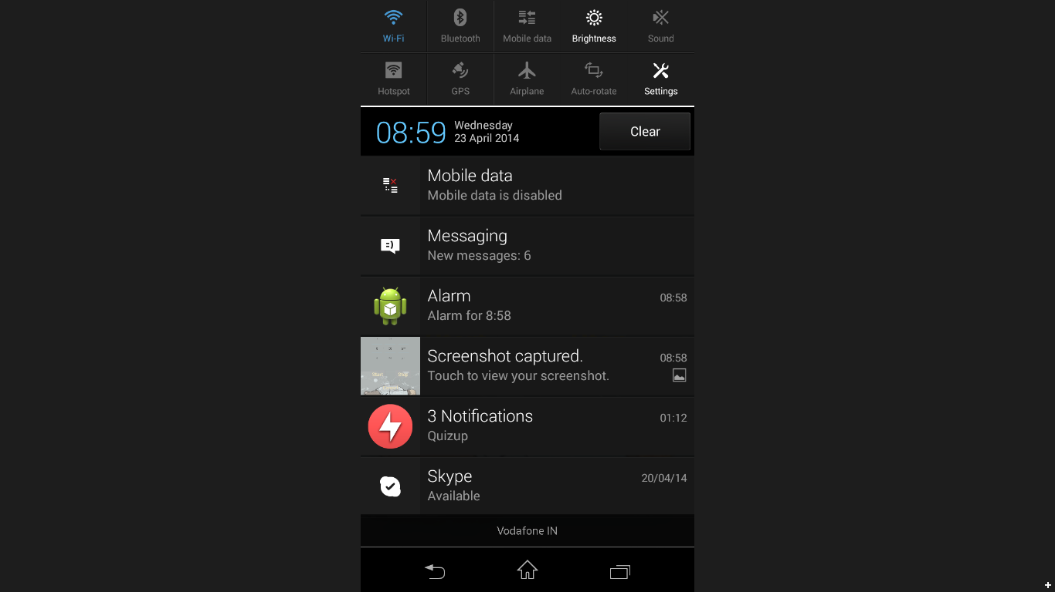

**Fig 4.3 Myservice XML layout.**

**This class actually creates a notification of the alarm in the notification panel which when clicked opens up the puzzle.**

**4.4 MY RECEIVER.JAVA**

This creates a broadcast and starts the alarm.

**4.5 ALARMMAINACTIVITY.JAVA**

This class has the functions start, stop and cancel that are used by the MyAlarm.java class to create or delete the alarm.

**PUZZLES**

The following puzzles were made in android and crop up when the alarm starts to ring. A random function is used to decide which puzzle comes up randomly. The following are the list of puzzles put in the demo version of the app. After solving the puzzle, an assurance test in the form of captcha comes up.

**Puzzle 1: Counting the number of squares in the given grid.**

A picture will be displayed and number of squares in that picture are to be counted. If the number of squares counted is correct, then the puzzle is solved successfully and is directed to Captcha, otherwise it keeps on ringing.

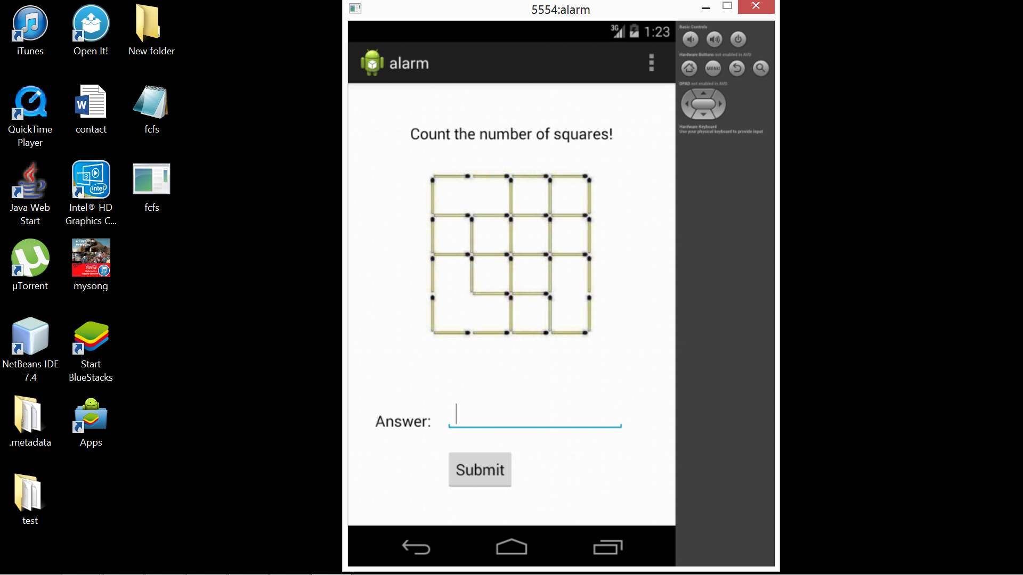

**Fig 5.1 Squares XML layout output**

**The screen asks user to count the number of squares in the picture. The edit field takes only number as input. A wrong answer asks user to enter again while correct answer displays a toast saying correct answer. If nothing is input, the toast displays enter a valid input.**

**Puzzle 2: Counting the number of differences between two similar pictures.**

Two similar pictures will be displayed and the user has to count the total number of differences between them. On entering the correct picture the screen is directed to Captcha after which the alarm can be stopped or snoozed.

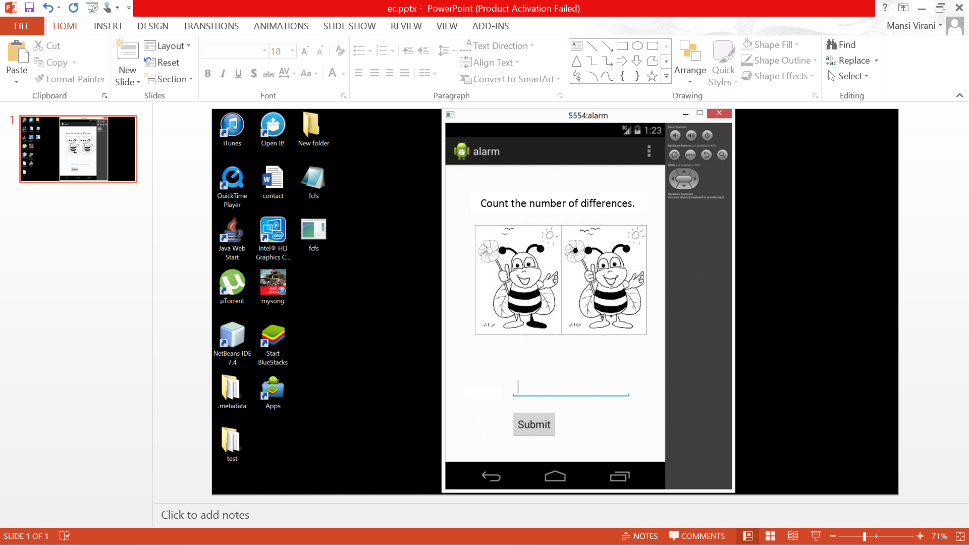

**Fig 5.2 Diff.xml layout output**

**The puzzle has an edit field that takes only number as input from the user. The correct answer displays the answer is correct. The wrong answer asks user to enter again for the same puzzle. However, if no input is given, the user is asked to enter again because it is invalid.**

**Puzzle 3: Mathematical Equations**

This puzzle generates a random mathematical equations and asks you to solve it. Correct answer makes the alarm to go off. However it does not take float values. It has only 2 operands.

The operation is among addition, subtraction, multiplication and division. The output of the same is given below:

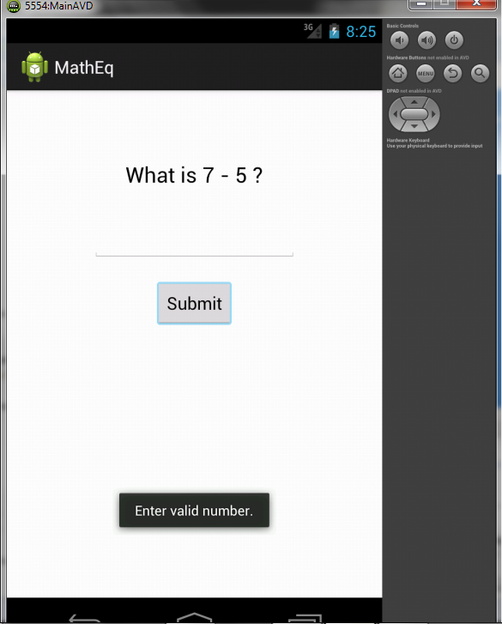 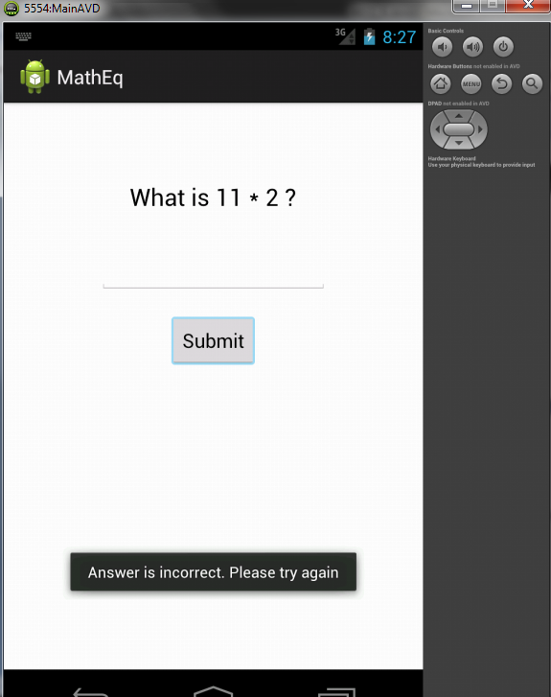

**Fig 5.3 MathEq.xml output Fig 5.4 MathEq.xml output for incorrect input**

**When there is no input, the toast displays above. When there is a wrong input, new equation is generated and you have to**

**enter again for a new equation**

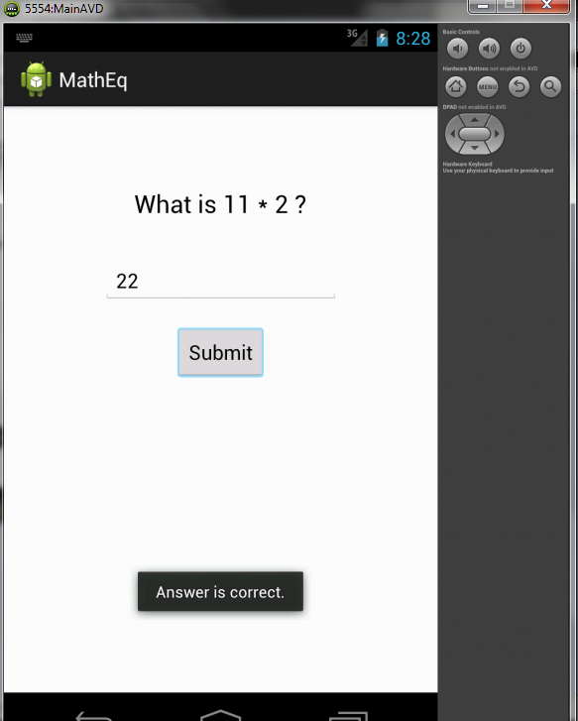

**Fig 5.5 MathEq XML layout with correct input**

**It displays the correct input given by the user and hence a toast comes up saying that the answer entered by the user is correct.**

**Assurance test: CAPTCHA**

A CAPTCHA is shown. After a certain period, if the code is not guessed correctly, a new CAPTCHA is generated. This goes on and on until the code is correctly guessed and the person has finally woken up!

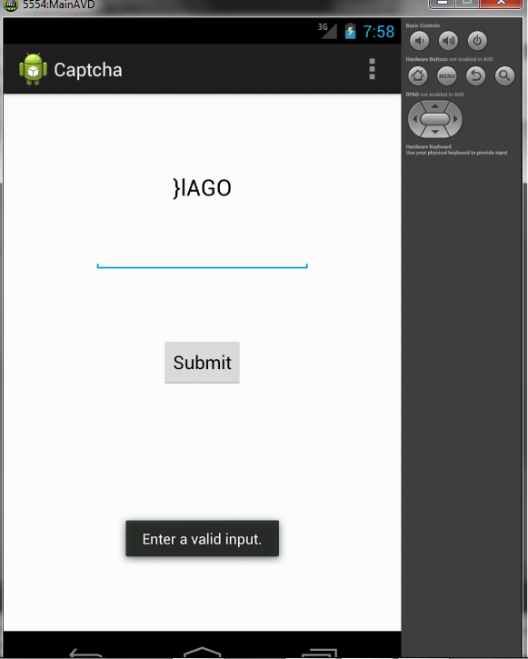 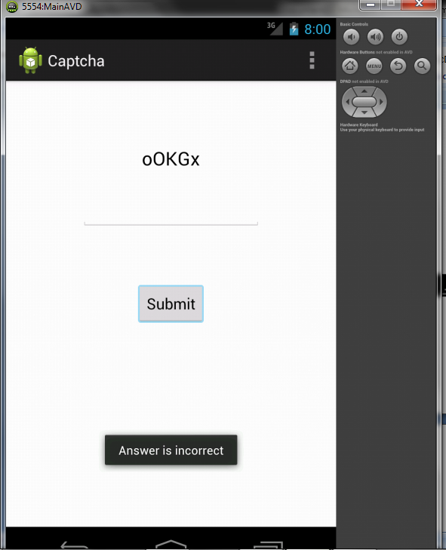

**Fig 5.6 Captcha layout Fig 5.7 Captcha with invalid input**

**It asks to enter a valid input. Here a new captcha is generated. Enter again.**

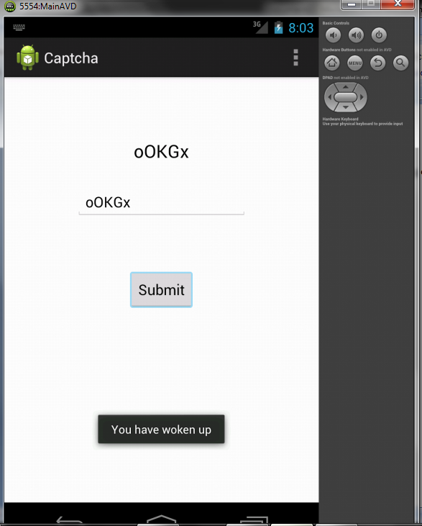

**Fig 5.8 Captcha with correct input**

**INTEGRATION**

The puzzles were made and now we had to import them into the main alarm clock. To achieve this, we have to create intents to link pages in a sequence to display them. Now we have our main screen Myalarm.java. From there, we have to call an intent to any of the puzzle and from the puzzle basically, we have to call an intent Alarm_Buzzer.java to snooze if the answer is done correctly. The code for the same is put in the appendices for your reference.

Integration in android is achieved through calling intents from one page to the other.

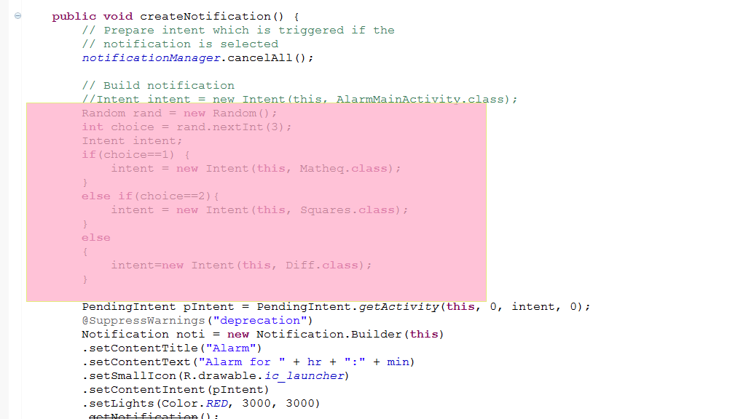

**Fig 6.1 Calling Intents in the alarm code**

**GRAPHICAL USER INTERFACE (GUI)**

The graphical user interface is made by importing the background pictures into the drawable folder and then using it through the properties. Doing so, the following interfaces of all the screens is made.

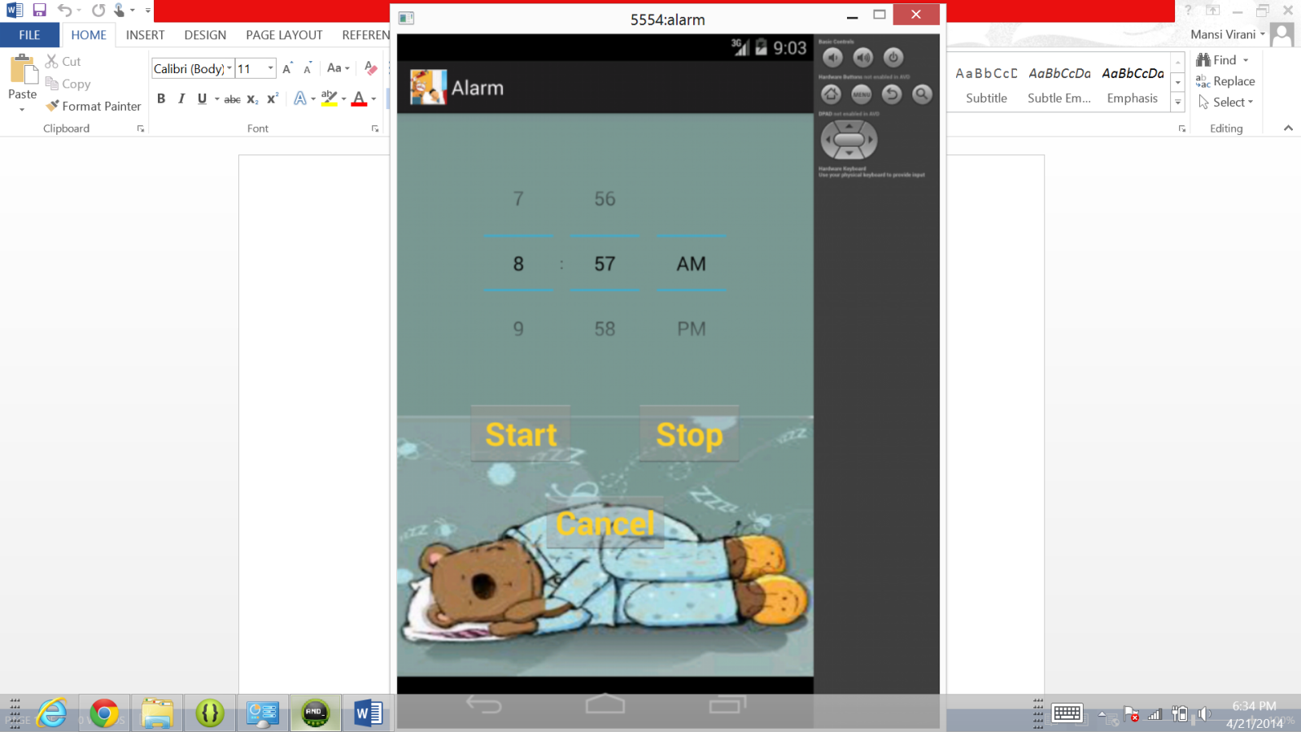

**Fig 7.1 MainAlarm Layout**

**This shows a background of a teddy sleeping is taken and imported.**

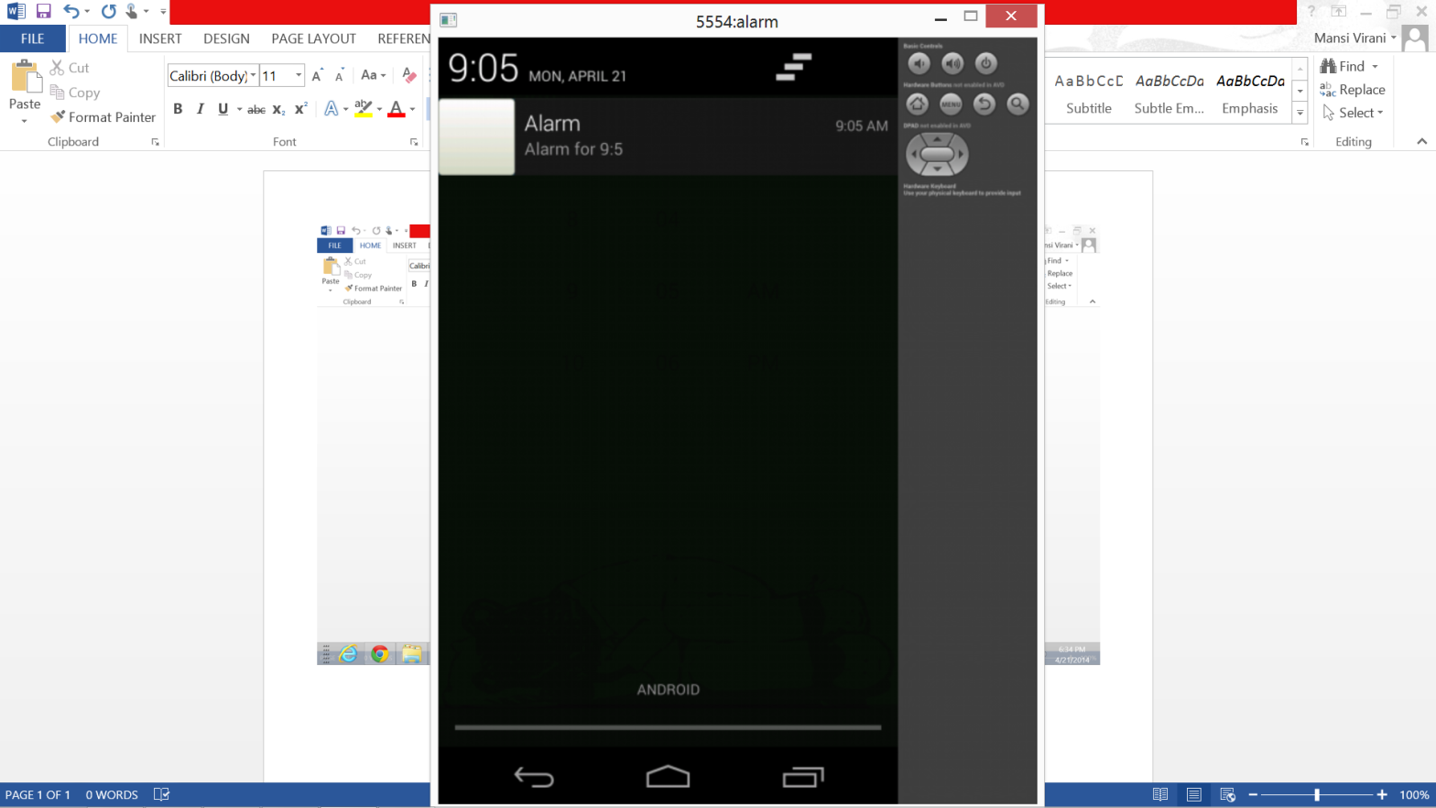 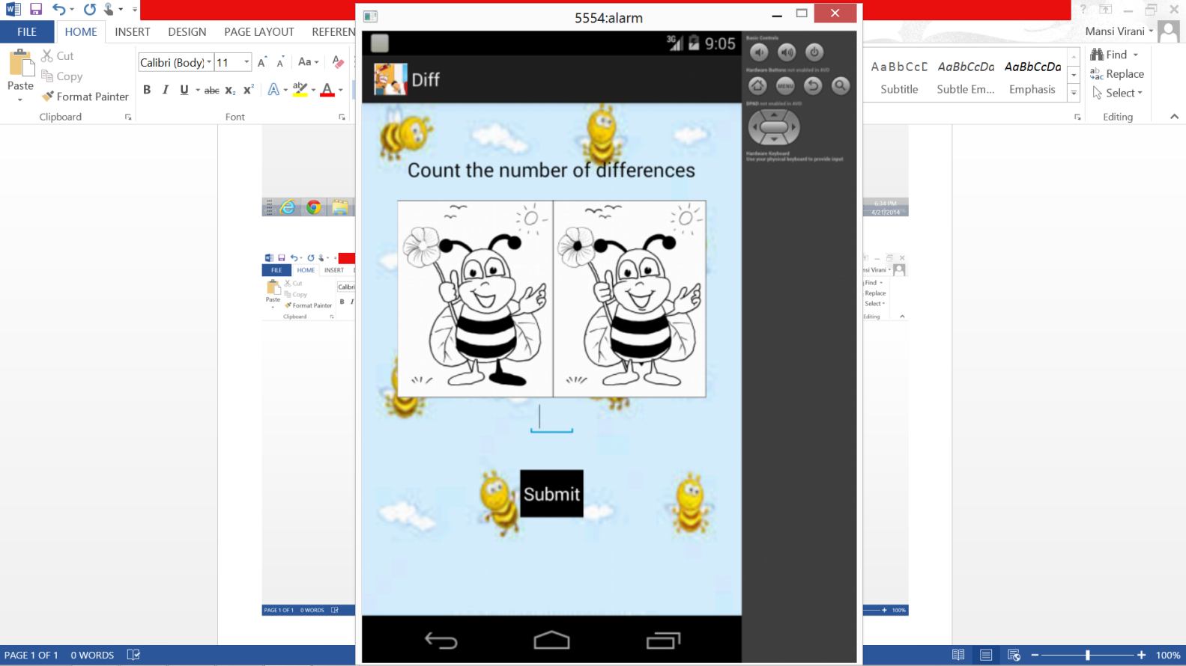

**Fig 7.2 Notification screen shows app icon Fig 7.3 Layout of the puzzle 1**

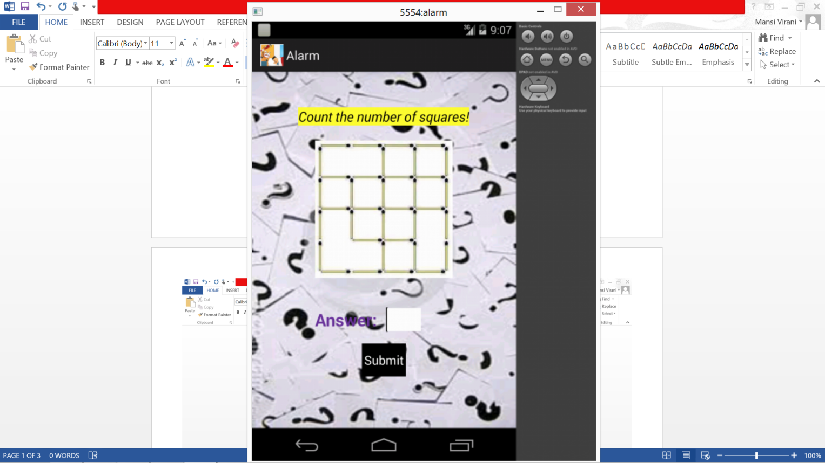 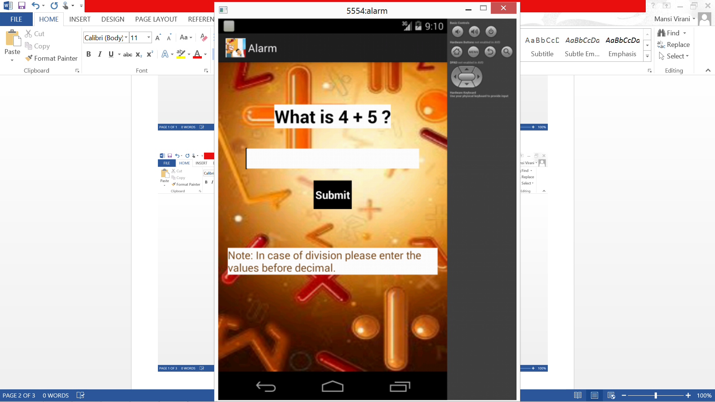

**Fig 7.4 GUI layout of puzzle 2 (Squares) Fig 7.5 GUI layout of puzzle 3 (MathEq)**

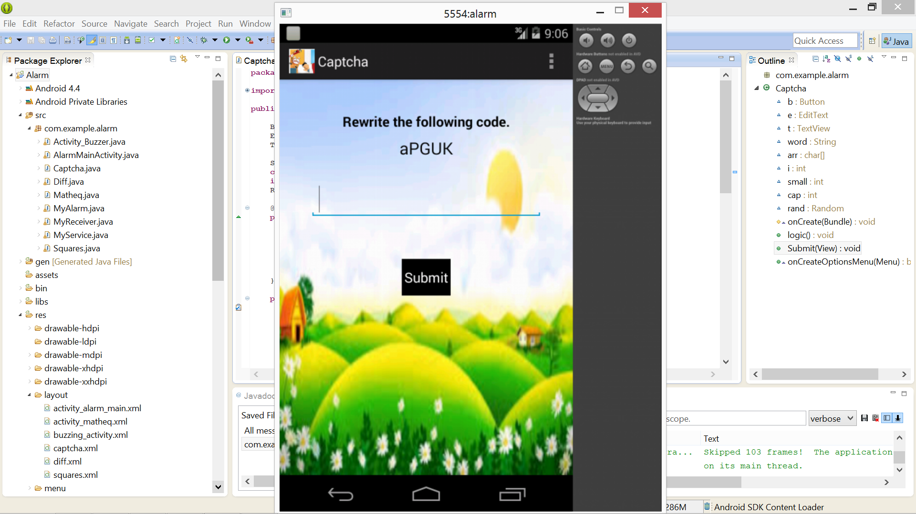

**Fig 7.5 GUI layout of Captcha.**

**CONCLUSION AND FUTURE SCOPE**

Thus we conclude that through this course, we learnt how to make an android app and run it on the hardware having an android operating system.

The future scope of this puzzle can include addition of new puzzles into the alarm or also use of motion sensors for certain puzzles leading to physical exercise as well as mental awareness early in the morning.

**APPENDIX I**

**TITLE:**

ALARM CLOCK CODE

**CODE:**

import java.util.Calendar;

import java.util.Random;

import android.app.AlarmManager;

import android.app.Notification;

import android.app.NotificationManager;

import android.app.PendingIntent;

import android.app.Service;

import android.content.Context;

import android.content.Intent;

import android.graphics.Color;

import android.media.AudioManager;

import android.media.MediaPlayer;

import android.media.RingtoneManager;

import android.net.Uri;

import android.os.Bundle;

import android.os.CountDownTimer;

import android.os.IBinder;

import android.os.Vibrator;

import android.util.Log;

import android.widget.Toast;

public class MyAlarm extends Service

{

public static final String TAG = "MyServiceTag";

static NotificationManager notificationManager;

String dayName, Schedule = "";

Bundle bundle;

int flag;

MediaPlayer mMediaPlayer;

CountDownTimer count;

Vibrator v;

int hr,min;

@Override

public IBinder onBind(Intent arg0)

{

// TODO Auto-generated method stub

return null;

}

@Override

public void onCreate()

{

Log.d(TAG, "onCreate");

}

@Override

public void onStart(Intent intent, int startId) {

Bundle bundle = intent.getExtras();

min = bundle.getInt("MIN", 60);

hr = bundle.getInt("HOUR", 24);

notificationManager = (NotificationManager) getSystemService(Context.NOTIFICATION_SERVICE);

notification(this);

Log.d(TAG, "onStart");

}

private void notification(Context arg0)

{

mMediaPlayer = new MediaPlayer();

createNotification();

}

public void createNotification()

{

// Prepare intent which is triggered if the

// notification is selected

notificationManager.cancelAll();

// Build notification

//Intent intent = new Intent(this, AlarmMainActivity.class);

Random rand = new Random();

int choice = rand.nextInt(3);

Intent intent;

if(choice==1)

{

intent = new Intent(this, Matheq.class);

}

else if(choice==2)

{

intent = new Intent(this, Squares.class);

}

else

{

intent=new Intent(this, Diff.class);

}

PendingIntent pIntent = PendingIntent.getActivity(this, 0, intent, 0);

@SuppressWarnings("deprecation")

Notification noti = new Notification.Builder(this)

.setContentTitle("Alarm")

.setContentText("Alarm for " + hr + ":" + min)

.setSmallIcon(R.drawable.ic_launcher)

.setContentIntent(pIntent)

.setLights(Color.RED, 3000, 3000)

.getNotification();

try

{

Uri alert = RingtoneManager.getDefaultUri(RingtoneManager.TYPE_ALARM);

mMediaPlayer = new MediaPlayer();

mMediaPlayer.setDataSource(this, alert);

final AudioManager audioManager = (AudioManager)

getSystemService(Context.AUDIO_SERVICE);

if (audioManager.getStreamVolume(AudioManager.STREAM_RING) != 0) {

mMediaPlayer.setAudioStreamType(AudioManager.STREAM_RING);

mMediaPlayer.setLooping(true);

mMediaPlayer.prepare();

mMediaPlayer.start();

count = new CountDownTimer(15000, 1000){

@Override

public void onTick(long millisUntilFinished)

{

}

@Override

public void onFinish() {

//Codes for checking the changes in the database on the server

mMediaPlayer.stop();

}

};

count.start();

}

} catch(Exception e) {

}

v = (Vibrator) getSystemService(Context.VIBRATOR_SERVICE);

// Vibrate for 15 seconds

v.vibrate(new long[] { 1000, 1000, 1000, 1000, 1000 }, 1);

notificationManager.notify(0, noti);

}

public void cancelNotification() {

notificationManager.cancelAll();

}

@Override

public void onDestroy() {

v.cancel();

mMediaPlayer.stop();

cancelNotification();

Toast.makeText(this, "Stopped", Toast.LENGTH_LONG).show();

Log.d(TAG, "onDestroy");

}

}

**APPENDIX II**

**TITLE:**

PUZZLE 1 CODE: -Random mathematical equations

**CODE:**

public class Matheq extends Activity {

Button b;

TextView t;

EditText e;

int n1,n2,oper,ans;

char op;

Random rand= new Random();

public void Submit(View v)

{

if(e.getText().length()==0)

{

Toast.makeText(this,"Enter valid number.",Toast.LENGTH_LONG).show();

}

int input = Integer.parseInt(e.getText().toString());

if(input==ans)

{

Toast.makeText(this, "Answer is correct.", Toast.LENGTH_LONG).show();

Intent intent = new Intent(this, Captcha.class);

startActivity(intent);

finish();

}

else

{

Toast.makeText(this, "Answer is incorrect. Please try again", Toast.LENGTH_LONG).show();

function();

}

}

@Override

protected void onCreate(Bundle savedInstanceState) {

super.onCreate(savedInstanceState);

setContentView(R.layout.activity_matheq);

e=(EditText)findViewById(R.id.editText1);

b=(Button)findViewById(R.id.button1);

t=(TextView)findViewById(R.id.textView1);

function();

}

private void function() {

// TODO Auto-generated method stub

n1=(int)(11*Math.random()+1);

n2=(int)(11*Math.random()+1);

oper=rand.nextInt(4)+1;

switch(oper)

{

case 1:

op='+';

ans=n1+n2;

t.setText("What is "+n1+" + "+n2+" ?");

break;

case 2:

op='-';

ans=n1-n2;

t.setText("What is "+n1+" - "+n2+" ?");

break;

case 3:

op='*';

ans=n1*n2;

t.setText("What is "+n1+" * "+n2+" ?");

break;

case 4:

op='/';

ans=n1/n2;

t.setText("What is "+n1+" / "+n2+" ?");

break;

}

}

}

**APPENDIX III**

**TITLE:**

PUZZLE 2 CODE:- Count the number of squares

**CODE:**

public class Squares extends Activity{

Button b1;

int result_code=0;

EditText text;

@Override

public void onCreate(Bundle savedInstanceState)

{

super.onCreate(savedInstanceState);

setContentView(R.layout.squares);

b1=(Button)findViewById(R.id.button1);

text=(EditText)findViewById(R.id.editText1);

}

public void Submit(View v)

{

if(text.getText().length()==0)

{

Toast.makeText(this,"Please enter a valid number.",Toast.LENGTH_LONG).show();

return;

}

int inputValue=Integer.parseInt(text.getText().toString());

if(inputValue==16)

{

Toast.makeText(this,"Correct Answer!", Toast.LENGTH_LONG).show();

Intent i=new Intent(this, Captcha.class);

startActivity(i);

finish();

}

else

{

Toast.makeText(this,"Wrong Answer.Please enter again!",Toast.LENGTH_LONG).show();

return;

}

}

}

**APPENDIX IV**

**TITLE:**

PUZZLE 3 CODE:-Spot the difference

**CODE:**

public class Diff extends Activity{

Button b1;

int result_code=0;

EditText text;

@Override

public void onCreate(Bundle savedInstanceState)

{

super.onCreate(savedInstanceState);

setContentView(R.layout.diff);

b1=(Button)findViewById(R.id.button1);

text=(EditText)findViewById(R.id.editText1);

}

public void Submit(View v)

{

if(text.getText().length()==0)

{

Toast.makeText(this,"Please enter a valid number.",Toast.LENGTH_LONG).show();

return;

}

int inputValue=Integer.parseInt(text.getText().toString());

if(inputValue==10)

{

Toast.makeText(this,"Correct Answer!", Toast.LENGTH_LONG).show();

Intent i=new Intent(this, Captcha.class);

startActivity(i);

finish();

}

else

{

Toast.makeText(this,"Wrong Answer.Please enter again!",Toast.LENGTH_LONG).show();

return;

}

}

}

**APPENDIX V**

**TITLE:**

CAPTCHA CODE

**CODE:**

import java.util.Random;

import android.os.Bundle;

import android.app.Activity;

import android.content.Intent;

import android.view.Menu;

import android.view.View;

import android.widget.Button;

import android.widget.EditText;

import android.widget.TextView;

import android.widget.Toast;

public class Captcha extends Activity

{

Button b;

EditText e;

TextView t;

String word;

char []arr=new char[5];

int i,small,cap;

Random rand=new Random();

@Override

protected void onCreate(Bundle savedInstanceState) {

super.onCreate(savedInstanceState);

setContentView(R.layout.captcha);

b=(Button)findViewById(R.id.button1);

e=(EditText)findViewById(R.id.editText1);

t=(TextView)findViewById(R.id.textView1);

logic();

}

public void logic() {

// TODO Auto-generated method stub

int j;

for(j=0;j<5;j++)

{

i=rand.nextInt(2)+1;

small=rand.nextInt(29)+97;

cap=rand.nextInt(29)+65;

switch(i)

{

case 1:

arr[j]=(char) small;

break;

case 2:

arr[j]=(char) cap;

break;

}

}

word= new String(arr);

t.setText(""+word);

}

public void Submit(View v)

{

int x;

String s=new String();

s=e.getText().toString();

if(e.getText().length()==0)

{

Toast.makeText(this,"Enter a valid input.",Toast.LENGTH_LONG).show();

return;

}

x=s.compareTo(word);

if(x==0)

{

Toast.makeText(this,"Good Morning!Have a nice day!",Toast.LENGTH_LONG).show();

Intent i=new Intent(this,Activity_Buzzer.class);

startActivity(i);

finish();

}

else

{

Toast.makeText(this,"Answer is incorrect.",Toast.LENGTH_LONG).show();

e.setText("");

logic();

}

}

@Override

public boolean onCreateOptionsMenu(Menu menu) {

// Inflate the menu; this adds items to the action bar if it is present.

getMenuInflater().inflate(R.menu.captcha_main, menu);

return true;

}

}

**REFERENCES**

**[1] Android Tutorial videos (youtube)**

**[2] Eclipse and java tutorials**